PROGRAM TO PRINT ODD NUMBERS FROM 1-100

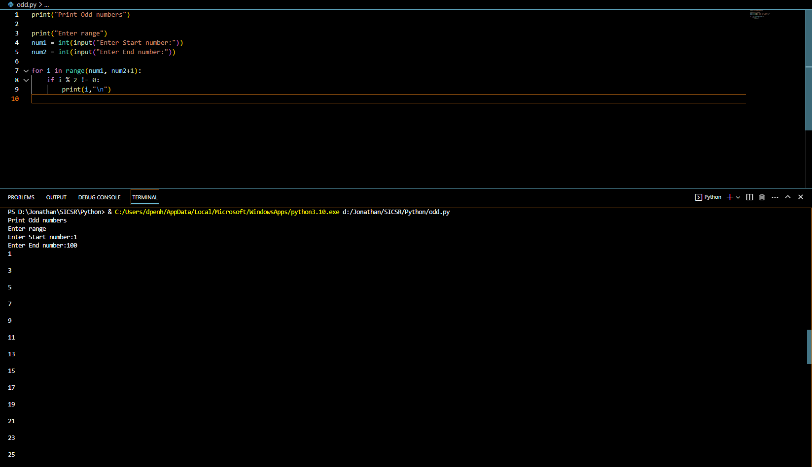

PROGRAM TO PRINT EVEN NUMBERS FROM 1-100

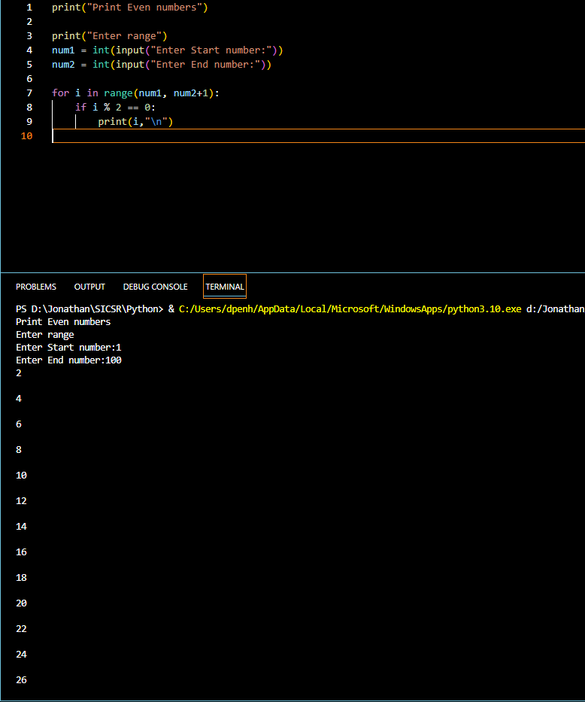

PYTHON PROGRAM FOR ARITHMETIC OPERATIONS

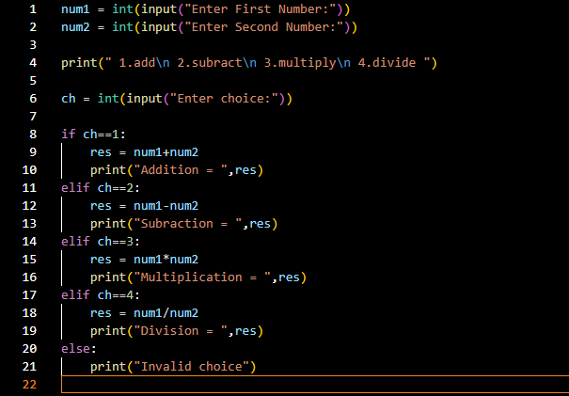

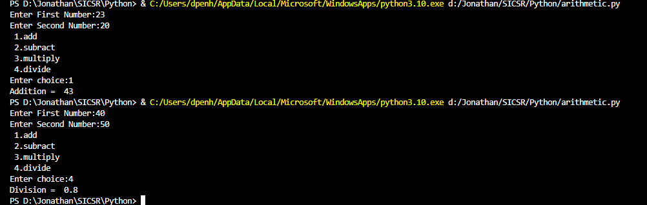

PYTHON PROGRAM TO CHECK IF NUMBER IS EVEN OR NOT  
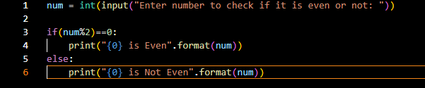



PYTHON PROGRAM TO FIND LARGEST OF 2 NUMBERS

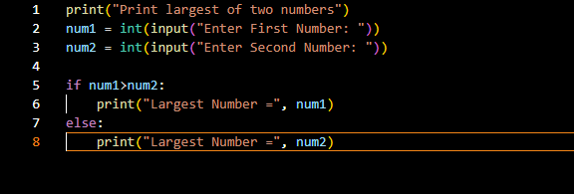

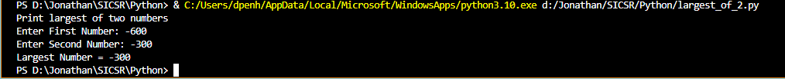

PYTHON PROGRAM TO FIND LARGEST OF 3 NUMBERS

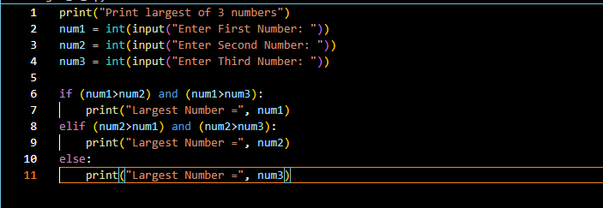

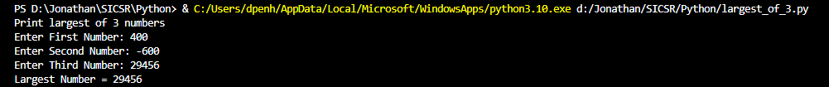

PYTHON PROGRAM TO MULTIPLY TWO NUMBERS

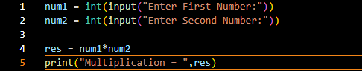



Python program to find Cube of a Number

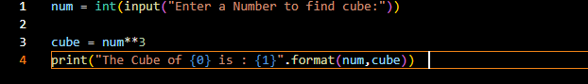



Python program to find Sum of Digits in a Number

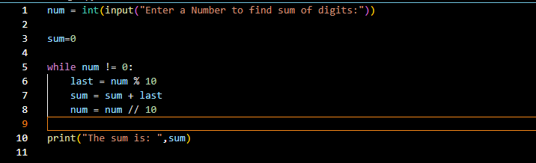

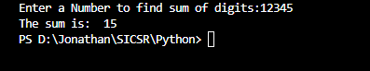

Python program to check whether the given integer is a multiple of 5

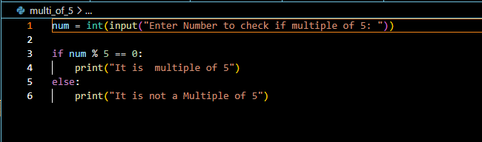

Python program to check whether the given integer is a multiple of both 5 and 7

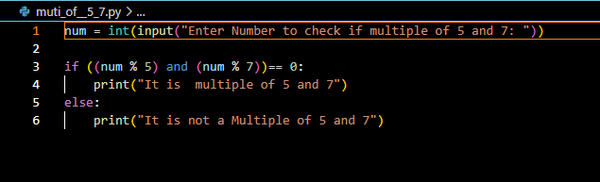



Python program to display all the multiples of 3 within the range 10 to 50

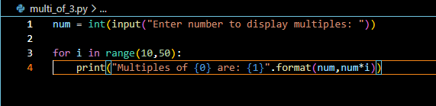

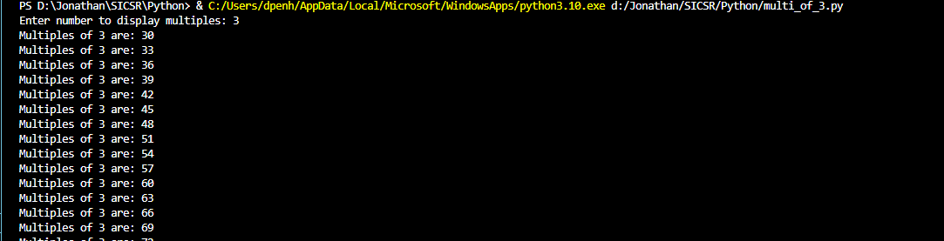

Python program to find the average of 10 numbers using while loop

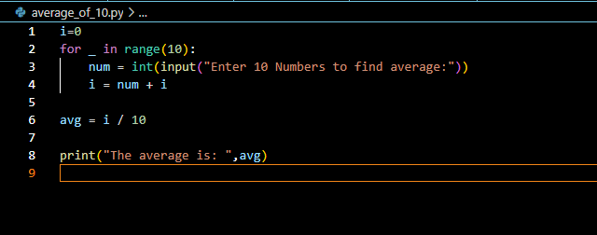

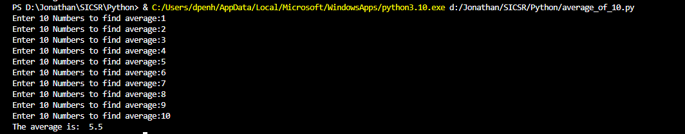

Python program to display all integers within the range 100-200 whose sum of digits is an even number

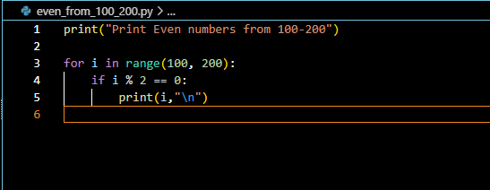

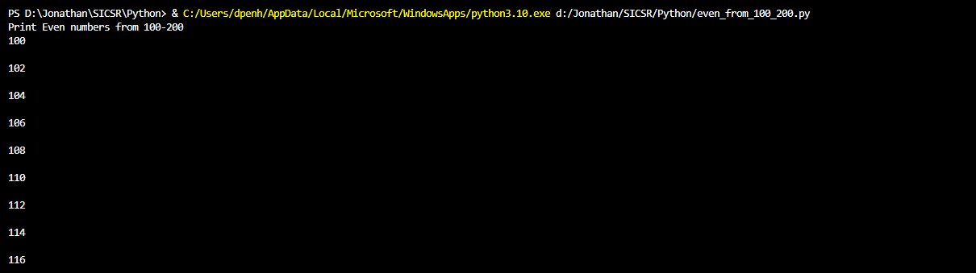

Python Program to Display the reverse of a number

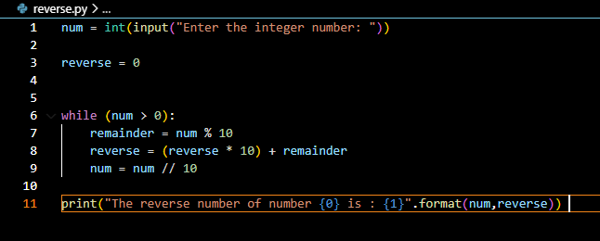

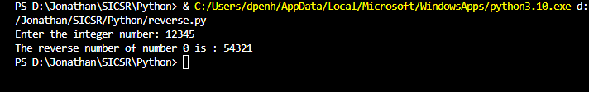

Python program to check whether the given integer is a prime number or not

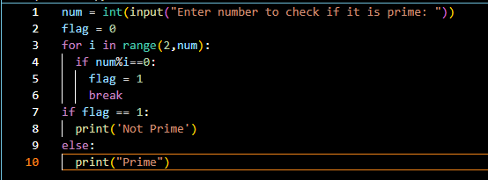



Python program to generate the prime numbers from 1 to N

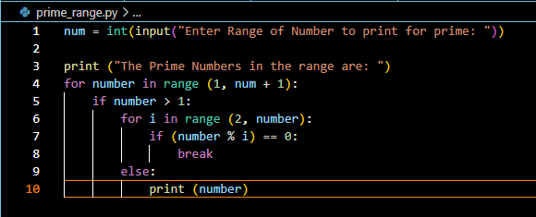

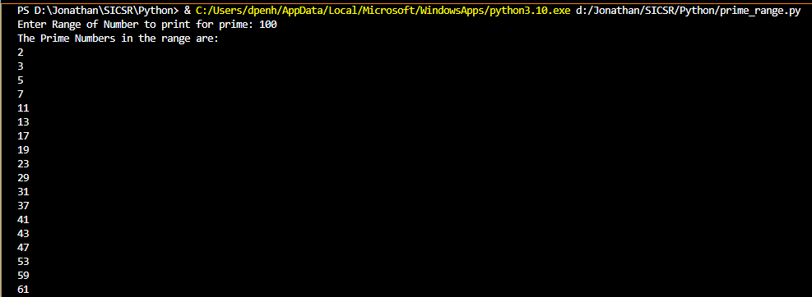

Python Program for leap year

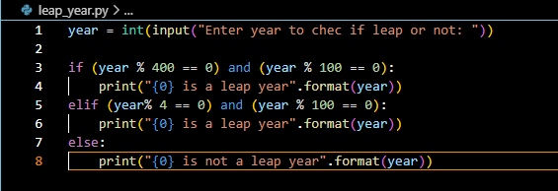

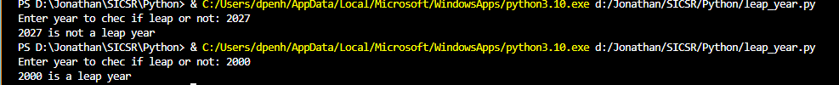

Python Program for Amstrong

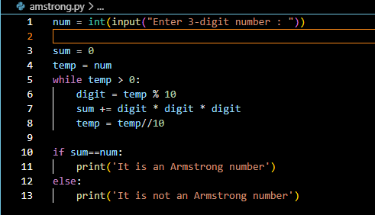

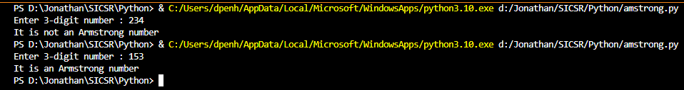

Python Program to Count Number of Digits in a Number

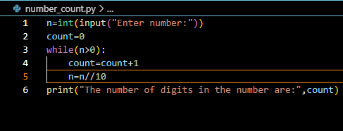



Python Program for Fibs Series

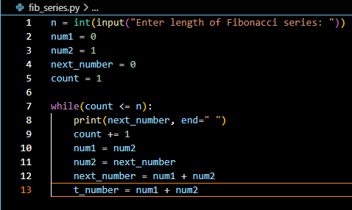



Python Program to find factors of number

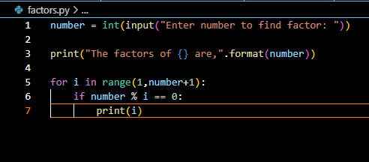

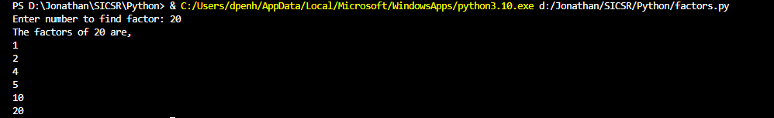

Python Program to find factorial

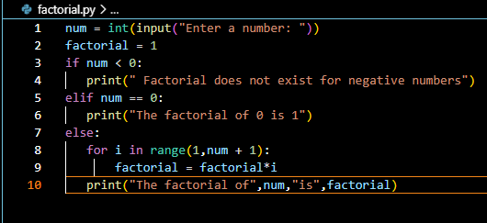



Python program to find GCD

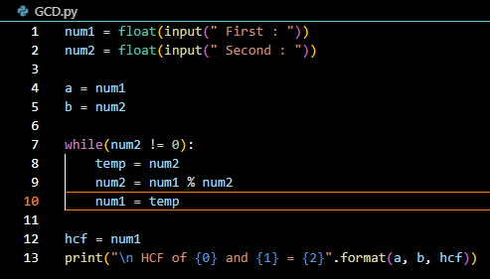



Python Program to find LCM

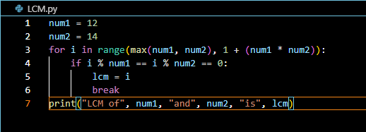



Python Program for Palindrome

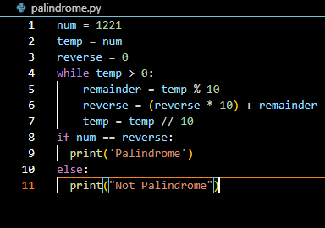



Python Program to find sum of fib series

